**CoreDNS**

**Installation Guide for CoreDNS and Go**

**Installing Go**

**1.**Open the terminal**.**

**2.**Download the latest Go tarball from the official Go website. Execute the following command, replacing VERSION with the latest version number

* **wget https://golang.org/dl/goVERSION.linux-amd64.tar.gz**

**3**.Extract and install Go. Run the following command to extract the downloaded tarball to /usr/local:

* **sudo tar -C /usr/local -xzf goVERSION.linux-amd64.tar.gz**

**4.**Set the Go environment. Add Go to your system's PATH by executing:

* **export PATH=$PATH:/usr/local/go/bin**

**5.**Verify the installation. Check the installed Go version to ensure it's set up correctly:

* **go version**

**Installing CoreDNS**

**1.**Clone the CoreDNS repository

* **git clone https://github.com/coredns/coredns.git cd coredns**

**2.**Build CoreDNS. Compile the CoreDNS binary by running:

* **go build**

**3.**Run CoreDNS. Start CoreDNS by executing the compiled binary:

* **./coredns**

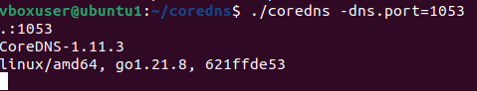

**Setting Up an Authoritative DNS Server Using CoreDNS**

**1.Create the Corefile.**

In the coredn**s** directory, create a file named Corefile with the following content:

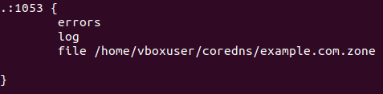

**2**.**Create the zone file.** In the coredns directory, create a file named **example.com** with the following content

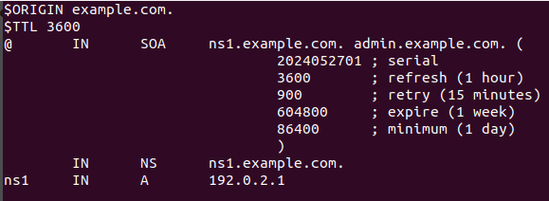

**3.Sample Output**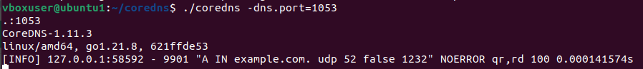

**Setting Up a DNS Forwarder Using CoreDNS**

**1.Create the Corefile.**

In the coredn**s** directory, create a file named Corefile with the following content:

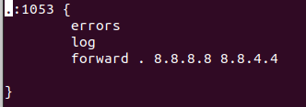

**Sample Output**

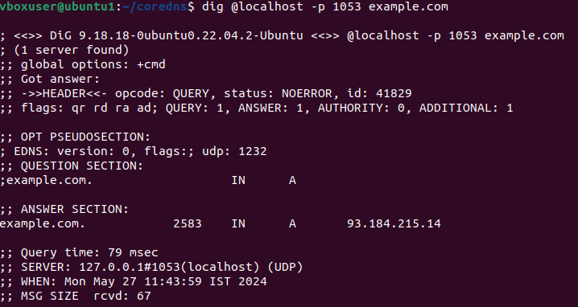

**Setting Up CoreDNS with Unbound as a Recursive Resolver**

1.Add unbound:github.com/coredns/unbound to **plugin.cfg**

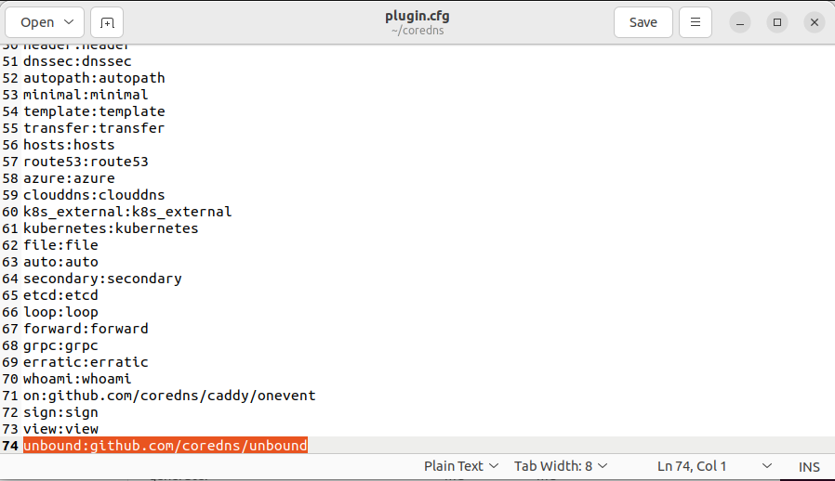2..Change cgo_enabled to 1 in **Makefile**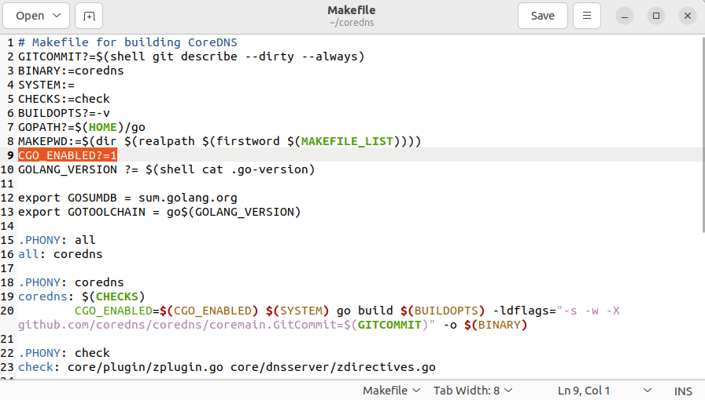

3.sudo apt install libunbound-dev

4.go get github.com/coredns/unbound

5.go generate

6.make

7.**Create the Corefile.** In the coredns directory, create a file named Corefile with the following content:

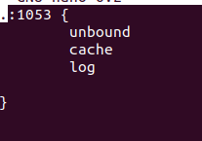

8.Sample Output

